**Sachin Chaudhary  
230701402  
EX NO. 10:**

**Project: Developing and Comparing CLI, GUI, and VUI for a To-Do List Task Management System**

AIM:

The aim is to develop and compare a Command Line Interface (CLI), a Graphical User Interface (GUI), and a Voice User Interface (VUI) for the same task (To-Do List management) and to assess user satisfaction with each interface, using Python (Tkinter for GUI, SpeechRecognition for VUI) and Terminal for CLI.

PROCEDURE:

i) Command Line Interface (CLI)

Description:

A terminal-based interface where users can add, view, and remove tasks via textual commands.

Code:

tasks = []

def add_task(task):

tasks.append(task)

print(f"Task '{task}' added.")

def view_tasks():

if tasks:

print("\nYour tasks:")

for idx, task in enumerate(tasks, 1):

print(f"{idx}. {task}")

else:

print("\nNo tasks to show.")

def remove_task(task_number):

if 0 < task_number <= len(tasks):

removed_task = tasks.pop(task_number - 1)

print(f"Task '{removed_task}' removed.")

else:

print("Invalid task number.")

def main():

while True:

print("\nOptions: ")

print("1. Add Task")

print("2. View Tasks")

print("3. Remove Task")

print("4. Exit")

choice = input("Enter your choice: ")

if choice == '1':

task = input("Enter task: ")

add_task(task)

elif choice == '2':

view_tasks()

elif choice == '3':

try:

task_number = int(input("Enter task number to remove: "))

remove_task(task_number)

except ValueError:

print("Invalid input. Please enter a valid number.")

elif choice == '4':

print("Exiting...")

break

else:

print("Invalid choice. Please try again.")

if _name_ == "_main_":

main()

Output:  
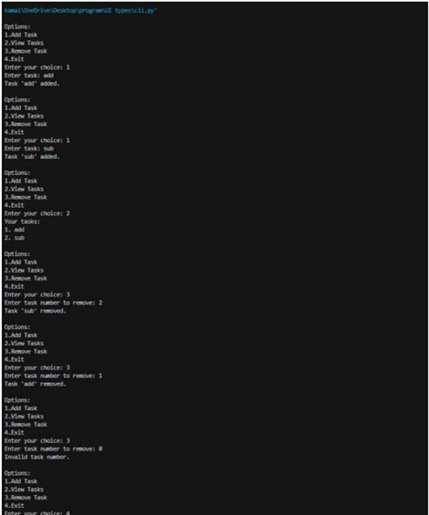

ii) Graphical User Interface (GUI)

Description:

A GUI application built with Tkinter where users can add, view, and remove tasks through graphical widgets (Entry, Button, Listbox).

Code:

import tkinter as tk

from tkinter import messagebox

tasks = []

def add_task():

task = task_entry.get()

if task:

tasks.append(task)

task_entry.delete(0, tk.END)

update_task_list()

else:

messagebox.showwarning("Warning", "Task cannot be empty")

def update_task_list():

task_list.delete(0, tk.END)

for task in tasks:

task_list.insert(tk.END, task)

def remove_task():

selected_task_index = task_list.curselection()

if selected_task_index:

task_list.delete(selected_task_index)

tasks.pop(selected_task_index[0])

else:

messagebox.showwarning("Warning", "Please select a task to remove")

app = tk.Tk()

app.title("To-Do List")

task_entry = tk.Entry(app, width=40)

task_entry.pack(pady=10)

add_button = tk.Button(app, text="Add Task", command=add_task)

add_button.pack(pady=5)

remove_button = tk.Button(app, text="Remove Task", command=remove_task)

remove_button.pack(pady=5)

task_list = tk.Listbox(app, width=40, height=10)

task_list.pack(pady=10)

app.mainloop()

output:  
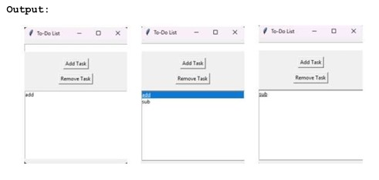

iii) Voice User Interface (VUI)

Description:

A voice-controlled interface where users can speak commands to add, view, and remove tasks using speech recognition and text-to-speech.

Code:

import speech_recognition as sr

import pyttsx3

tasks = []

recognizer = sr.Recognizer()

engine = pyttsx3.init()

def add_task(task):

tasks.append(task)

engine.say(f"Task '{task}' added.")

engine.runAndWait()

def view_tasks():

if tasks:

engine.say("Your tasks are:")

for i, task in enumerate(tasks, start=1):

engine.say(f"Task {i}: {task}")

else:

engine.say("No tasks to show.")

engine.runAndWait()

def remove_task(task_number):

if 0 < task_number <= len(tasks):

removed_task = tasks.pop(task_number - 1)

engine.say(f"Task '{removed_task}' removed.")

else:

engine.say("Invalid task number.")

engine.runAndWait()

def recognize_speech():

with sr.Microphone() as source:

print("Listening...")

audio = recognizer.listen(source)

try:

command = recognizer.recognize_google(audio)

return command.lower()

except sr.UnknownValueError:

engine.say("Sorry, I did not understand that.")

engine.runAndWait()

return None

def main():

while True:

engine.say("Options: add task, view tasks, remove task, or exit.")

engine.runAndWait()

command = recognize_speech()

if not command:

continue

if "add task" in command:

engine.say("What is the task?")

engine.runAndWait()

task = recognize_speech()

if task:

add_task(task)

elif "view tasks" in command:

view_tasks()

elif "remove task" in command:

engine.say("Which task number to remove?")

engine.runAndWait()

task_number = recognize_speech()

if task_number and task_number.isdigit():

remove_task(int(task_number))

elif "exit" in command:

engine.say("Exiting...")

engine.runAndWait()

break

else:

engine.say("Invalid option. Please try again.")

engine.runAndWait()

if _name_ == "_main_":

main()

Output:  
